**IF, ELSE, ELIF Statement in R**

**The if else statement**

An if-else statement is a great tool for the developer trying to return an output based on a condition. In R, the syntax is:

if (condition) {

Expr1

} else {

Expr2

}

[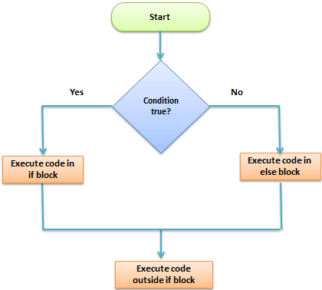](https://www.guru99.com/images/r_programming/032818_1241_IFELSEELIF1.png)

We want to examine whether a variable stored as "quantity" is above 20. If quantity is greater than 20, the code will print "You sold a lot!" otherwise Not enough for today.

# Create vector quantity

quantity <- 25

# Set the is-else statement

if (quantity > 20) {

print('You sold a lot!')

} else {

print('Not enough for today')

}

**Output:**

## [1] "You sold a lot!"

**Note**: Make sure you correctly write the indentations. Code with many conditions can become unreadable when the indentations are not in correct position.

**The else if statement**

We can further customize the control level with the else if statement. With else if, you can add as many conditions as we want. The syntax is:

if (condition1) {

expr1

} else it (condition2) {

expr2

} else if (condition3) {

expr3

} else {

expr4

}

We are interested to know if we sold quantities between 20 and 30. If we do, then the pint Average day. If quantity is > 30 we print What a great day!, otherwise Not enough for today.

You can try to change the amount of quantity.

# Create vector quantiy

quantity <- 10

# Create multiple condition statement

if (quantity <20) {

print('Not enough for today')

} else if (quantity > 20 &quantity <= 30) {

print('Average day')

} else {

print('What a great day!')

}

**Output:**

## [1] "Not enough for today"

**Example 2:**

VAT has different rate according to the product purchased. Imagine we have three different kind of products with different VAT applied:

|  |  |  |
| --- | --- | --- |
| **Categories** | **Products** | **VAT** |
| A | Book, magazine, newspaper, etc.. | 8% |
| B | Vegetable, meat, beverage, etc.. | 10% |
| C | Tee-shirt, jean, pant, etc.. | 20% |

We can write a chain to apply the correct VAT rate to the product a customer bought.

category <- 'A'

price <- 10

if (category =='A'){

cat('A vat rate of 8% is applied.','The total price is',price *1.08)

} else if (category =='B'){

cat('A vat rate of 10% is applied.','The total price is',price *1.10)

} else {

cat('A vat rate of 20% is applied.','The total price is',price *1.20)

}

**Output:**

# A vat rate of 8% is applied. The total price is 10.8